Happy Middle of the April Month: I have enjoyed talking/texting with all of you; especially the comments/feedback of the challenges. This week’s teacher page: Respond back by email mcrowell@carrollschools.com or text.

Monday: Dipped Apple Reflection------ Think back to when we dipped our apples…..after seeing & tasting 1) would you have done anything different? 2) We had 2 different caramel recipes….which was your favorite & why…..
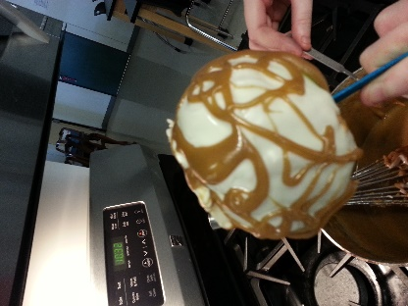

Tuesday: https://www.nps.gov/yell/learn/photosmultimedia/virtualtours.htm
Using the above link, copy & paste in browser, virtual tour of Yellowstone National Park
Go to https://www.nps.gov/thingstodo/yell-mud-volcano-trails.htm (Mud Volcano Trail)
Best detective work please answer: 1) Give me your back story on rotten eggs…..scientific element on the periodic table of what rotten eggs smell like----can you name any tv/movies that reference this smell? 2) Is this where “Mud Pie” originated?
Wednesday: https://www.farmfood360.ca/#apple-orchard-tile
Let me share with you what I learned from this virtual tour….the branches holding up those Honeycrisp apples must be really strong because those apples are huge! Share something you all found interesting!
Thursday: explore hospitality & tourism: exciting career building blocks
https://login.icevonline.com/Login?ReturnUrl=%2fmycourses
username: carrollreviewer1
password: 1234
Under my courses click on the view tab…..start exploring
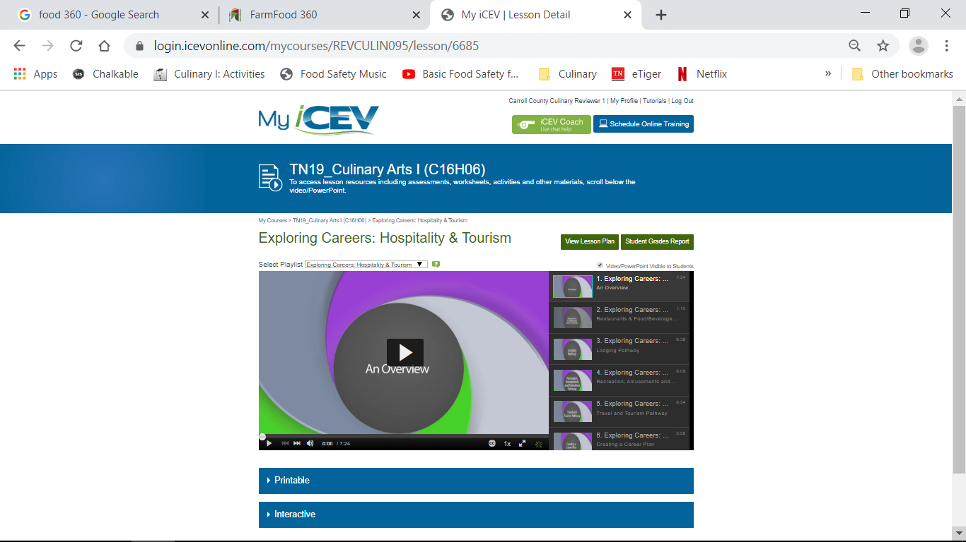
Friday: Once you have explored the above resource, research youtube or Disney.com to uncover any Culinary Arts career information that you find noteworthy. Below is mine->
https://www.youtube.com/watch?v=DbepbIsxOAc
Serve Safe Certification is a plus and will get your application moved to the top!

